Alexis Prazak
3/15/2026
CS330 2-3 Project Proposal
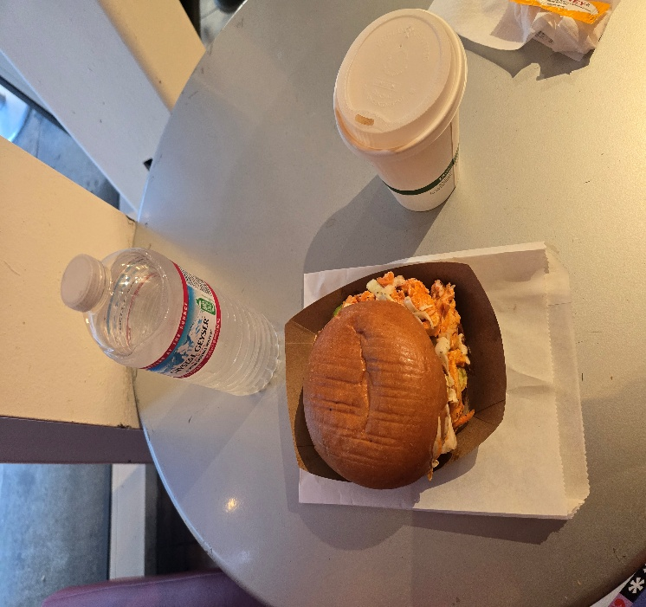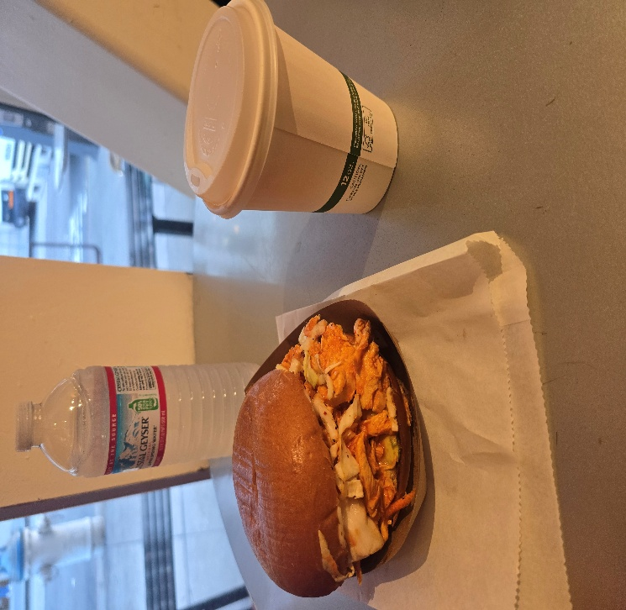
For this project I'll be using a picture from a cute I visited. I chose it for the variety of shapes and interesting textures. From the picture I'll be replicating the sand which (including the tray its in), coffee cup, table, and water bottle. The following shapes will be used:
- Tapered Cylinder: A cylinder that tapers off at the bottom will replicate the shape of the coffee cup. A regular cylinder will be used for the water bottle.
- Spheres: I want to use two spheres to represent the buns of the sandwich.
- Plane: The planes in the science will be for the table and the buffalo chicken filling. Since planes are flat a texture will be used on each to make them more lifelike.
- Prism: I will use a single trapezoidal prism for the tray holding the food.
One thing I want to research during this course is how to manipulate he standard shapes to create something unique. For example, the trapezoid for the food try has a hollow portion where the food sits. In most 3D modeling programs, you can adjust where a particular face sits. I want to learn how to adjust shapes this way with OpenGL.

